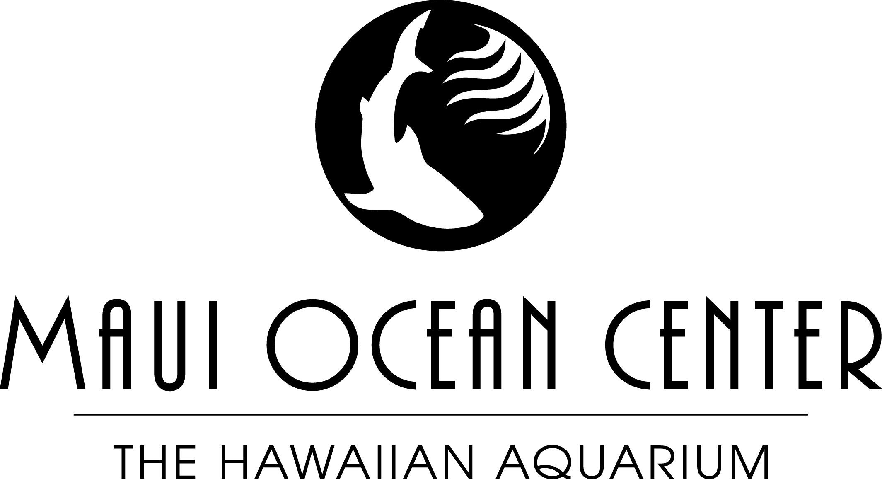

JOB DESCRIPTION: AQUARIST

Job Title: Aquarist
Department: Curatorial
Reports To: Curator/Head Aquarist
Status: Non Exempt
Date: 2015

BaSIC FUNCTIONS: Provides for the proper care of animals with a focus on those in the Living Reef Building, Aquarium Lab and Quarantine.

ANIMAL CARE

Cares for the animals and documents all behaviors observed.

Participates in the feedings, which includes food preparation and record observations daily

Inspects all tanks daily in regards to animal health

Knows the names, quantity and location of all animals on display

Checks the life support systems of the tanks each day

Care and maintenance of all lab animals and tanks.

exhibit maintenance

- Participates in the maintenance and cleaning of tanks in the Living Reef daily
- Checks the exhibits daily for cleanliness
- Assists the Head Aquarist in verifying the accurateness of graphic boards

team development & supervision

- Assists the Head Aquarist in the supervision of interns and volunteers when asked

inter and intra-department communication

- Attends a daily curatorial meeting to report problems or concerns encountered in the tanks assigned to them and to receive task assignments

other responsibilites

- Reports daily accomplishments, problems and concerns to the Head Aquarist
- Ensures that the service areas are kept clean and tools properly stored
- Participate in tours and presentations including, but not limited to Dive Link, Fins and Flippers, School and Private Tours

minimum qualifications
- Diver certification
- Able to carry 50 pounds
- Knowledge of the common/Hawaiian names of fishes and inverts
- Pass a mandated dive physical annually
- CPR, 1st Aid, & AED certification; and maintain current certification
- 4 year degree in Marine Biology or equivalent job experience.

